Interim Expert Governance Committee
Connecticut Citizens’ Assembly (CCA)
March 18, 2026
Decisions
Participants: Hélène Landemore (Chair), Alex Guerrero, Cynthia Farrar, Dan Selz, Jane Suiter, Joshua Kalla, Luigi Zingales, Michiel Bakker, Michael Morrell, Oliver Hart, Sophie Guillain, Zephyr Teachout, Thalsa Mekaouche (Observor), Gryffin Wilkens-Plumley (Notetaker)
Assembly Size and Membership
The committee unanimously voted to increase the assembly size from 75 to 100 participants, prioritizing representativeness and external credibility despite higher costs. There was an informal vote to say the group has consensus on not including legal minors in the Assembly.

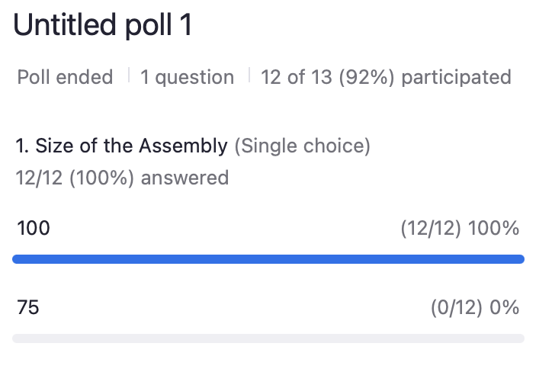
Scheduling and Logistics Adjustments
To resolve calendar conflicts and improve feasibility, the committee approved key scheduling changes. The September 12 session will move to September 19 as a virtual session, and the August 29 session will shift to in-person, primarily to avoid conflicts with Rosh Hashanah and accommodate logistical constraints. These changes reflect a broader effort to finalize the assembly timeline and venue requirements ahead of near-term deadlines, particularly for outreach and materials distribution.
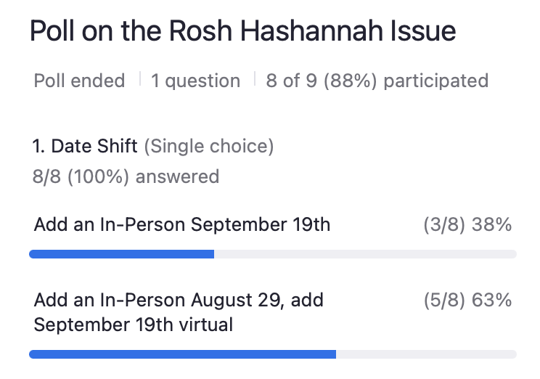

Invitation Letter and Participation Parameters
The committee identified the invitation letter as a critical lever for recruitment and legitimacy but postponed final decisions on its content. Members agreed to revise the tone to make it more engaging while maintaining institutional credibility and to test alternative versions before finalizing. On participation rules, the group decided not to include individuals under 18 in the pilot and clarified that no social security numbers would be collected during initial outreach. Broader questions—such as inclusion of undocumented participants, stipend framing, and messaging around the assembly’s focus—remain open for the next round of deliberation.
Appointing Subordinate Committee Chairs
The group also formalized its internal structure by establishing three subordinate committees—Research, Scale, and Community—and appointing chairs for each: Michael (Research), Dan (Scale), and Cynthia (Community). A fourth Policy Impact committee will be created subsequently. Several governance questions, including decision rules and rotating chairmanship, were explicitly deferred for future resolution.
Subcommittee Appointments (Informal hand vote)
- Cynthia Farrar Voted for Community
- Dan Selz voted for Scale
- Michael Morrell for Research
- Bryan CCM voted for Public Impact

