Interim Expert Governance Committee
Connecticut Citizens’ Assembly (CCA)
March 24, 2026
Decisions
Participants: Hélène Landemore (Chair), Alex Guerrero, Ariel Procaccia, Claire Priest, Cynthia Farrar, Dan Selz, Jane Suiter, Joshua Kalla, Luigi Zingales, Michiel Bakker, Michael Morrell, Oliver Hart, Sophie Guillain, Zephyr Teachout, Thalsa Mekaouche (Observor), Gryffin Wilkens-Plumley (Notetaker)
Assembly Title and Focus Finalized
The committee confirmed the official title of the initiative as the Connecticut Citizens’ Assembly on Property Taxes. After extensive discussion, members agreed that the assembly’s guiding question will center on how the state should fund and deliver local public services, with property taxes serving as the primary policy lens. This framing was chosen for its clarity and broad relevance to statewide fiscal concerns.
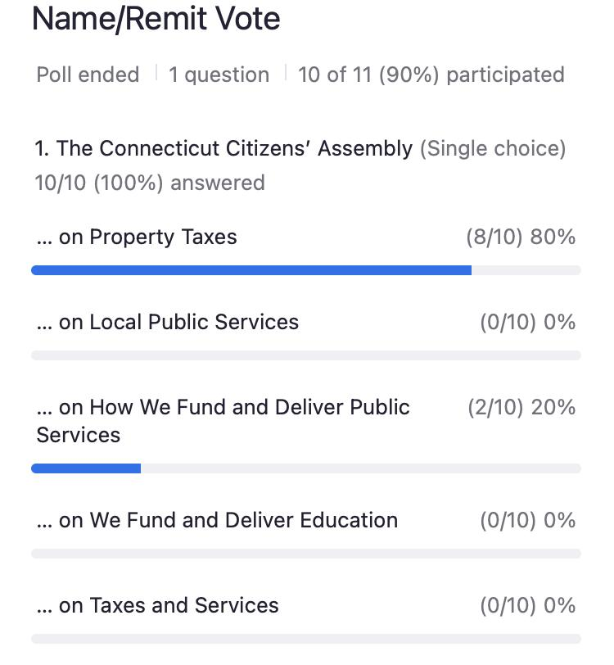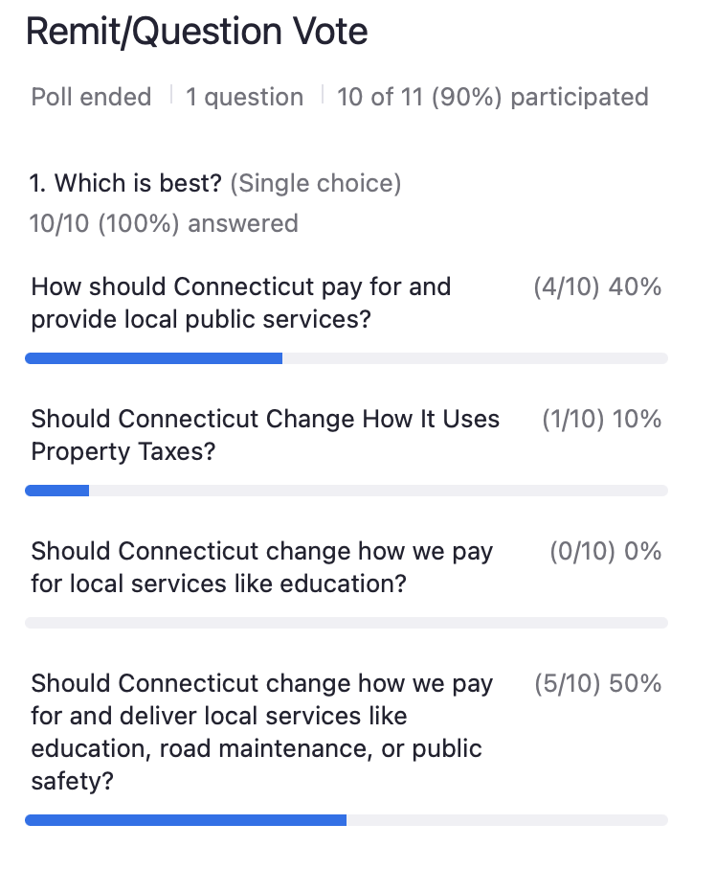
Schedule Revisions and Venue Planning
Due to conflicts with the Jewish High Holidays, the group revised the assembly schedule. Meetings will take place on July 11-12 in person, July 25 in person, August 8 virtually, August 29-30th in person, and September 19 virtually, with a final symbolic session planned for September 26th at the Connecticut State Capitol, pending political approval. The Chair will work with staff to confirm the new dates and secure venues
[New dates passed by acclimation]

Date | Milestone
July 11-12 (2 days) | 2 day in person Assembly begins
July 25 | 1 day-in person
August 8th (one day) | Virtual
August 29-30th (2 day) | 2 day In Person
September 19th (1 day) | Virtual
September 26th (1 days) | 1 day In Person
Mid October | Gubernatorial Debate
Post-January | Legislative hearing

Governance Committee Expansion
The committee discussed the need to broaden its membership by adding experts in property taxation and local finance. Joe DeLong will contact Alex Knopp to assess his interest in joining as an expert member, and the group will formally review potential additions at the next meeting. Pamela Greene is expected to assume the role of project manager beginning in June.
Next Steps and Document Revisions
Members will continue refining the invitation letter and guiding question, aiming to finalize both during the next meeting. Cynthia will streamline the shared drafts to reduce confusion, while the Chair will lead the final approval process. The group also revisited whether to rotate the chair role or maintain the current leadership arrangement, voting overwhelmingly for Professor Landemore to remain as the Chair, without foreclosing on future discussion.
